OTR Solutions

Carrier TMS Onboarding Documentation

Contents
Carrier TMS Overview 3
Authentication 4
Broker 8
Invoice 10
Broker Check 14

Carrier TMS Overview

The Carrier TMS Solution enables Carriers to easily submit invoices digitally through their TMS. The APIs allow a carrier to authenticate with OTR (using their existing account details), then submit an invoice as well as check on the status of submitted invoices, verify a broker’s eligibility, and more.

In order to begin integrating with OTR Solutions, you will need to request a subscription key which is needed to hit our endpoints. In addition to providing a Subscription key, OTR Solutions will provide access to our developer portal which outlines the operations available to you, and how to use it. Once you have successfully passed our integration verification process (which involves the demonstration of end to end invoice processing) we will provide the credentials to integrate into our production environment.
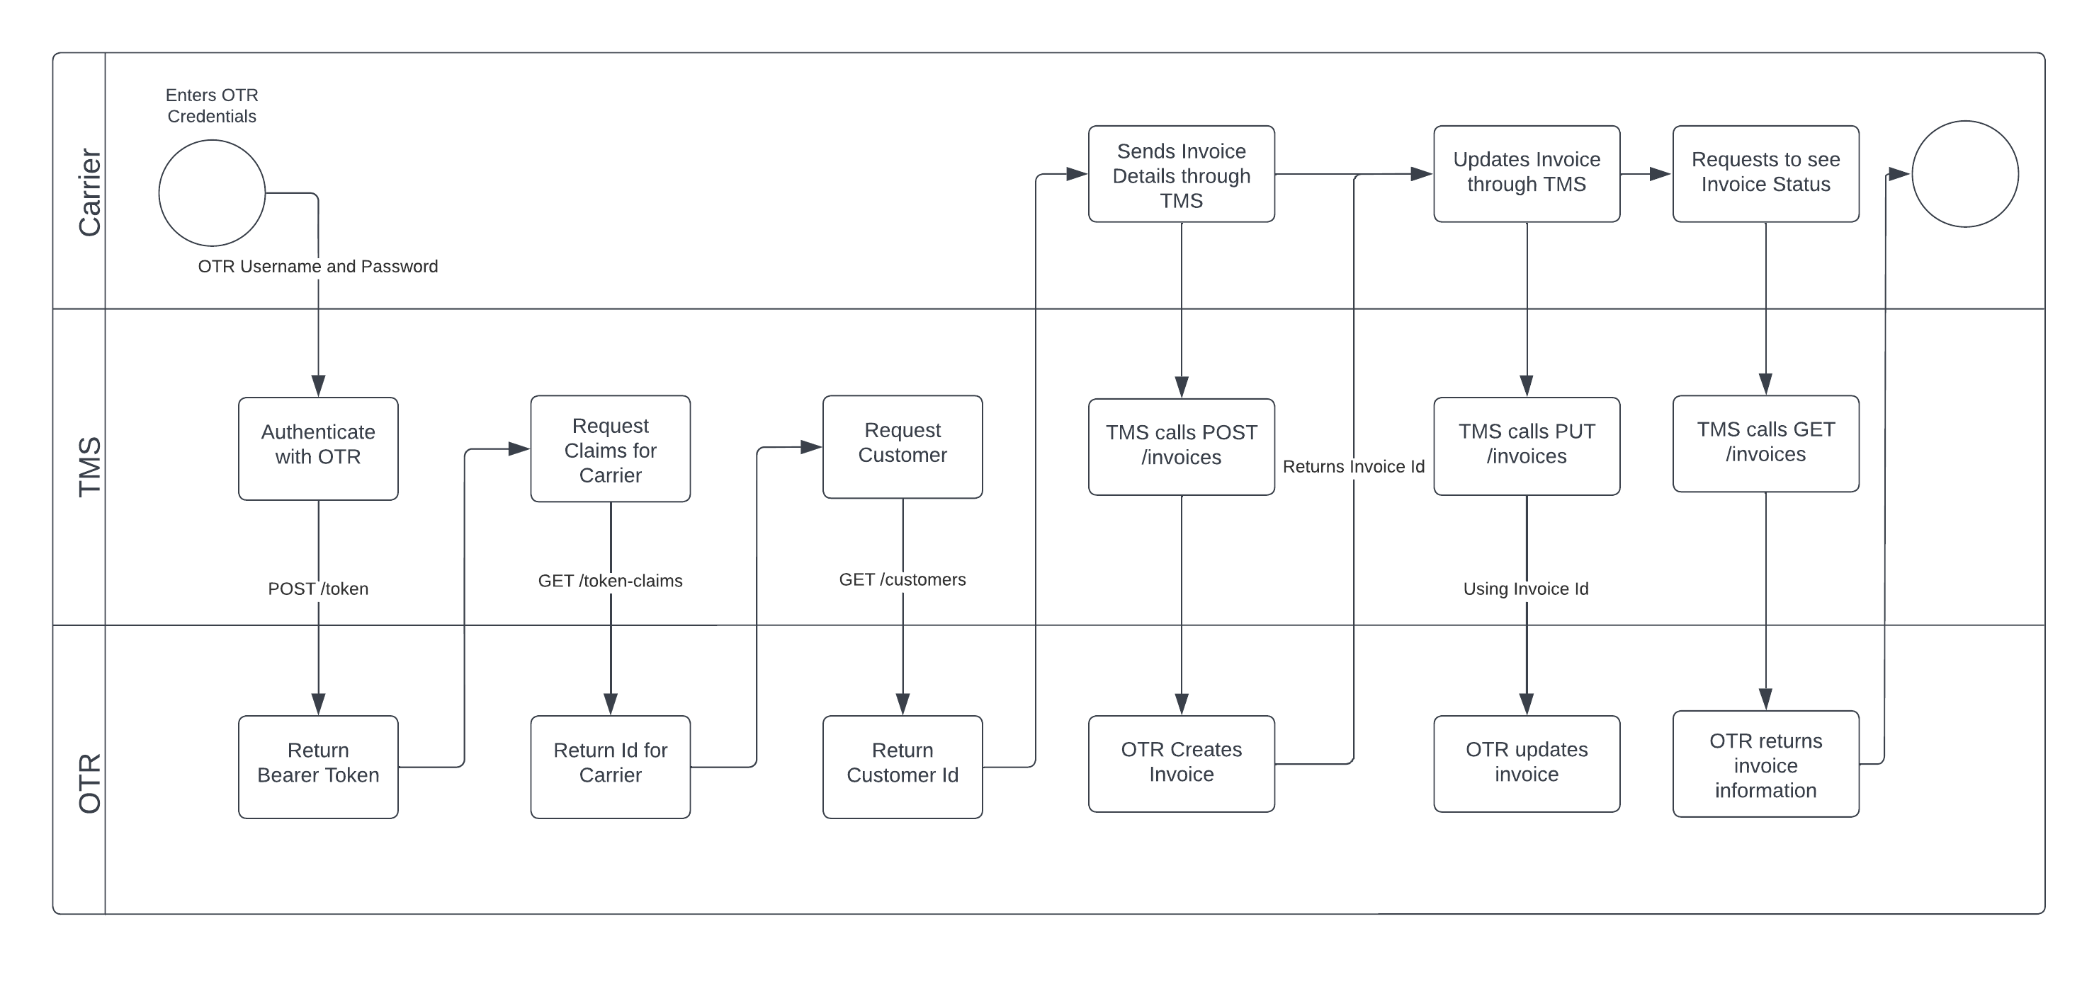
Feature | Requirement | Purpose
Authentication | Bearer Token Authentication | Used to Authenticate the user to OTR through the TMS.
Broker Information | Retrieve Broker Information | Used to Map the Customer’s McNumber to OTRs Id.
Invoices | Ability to send invoices to OTR | Carriers can upload invoices directly to OTR through TMS
Credit Check (Beta) | Retrieve credit check for the desired broker from OTR. | Check a Broker’s status in OTR before uploading an invoice.

Authentication

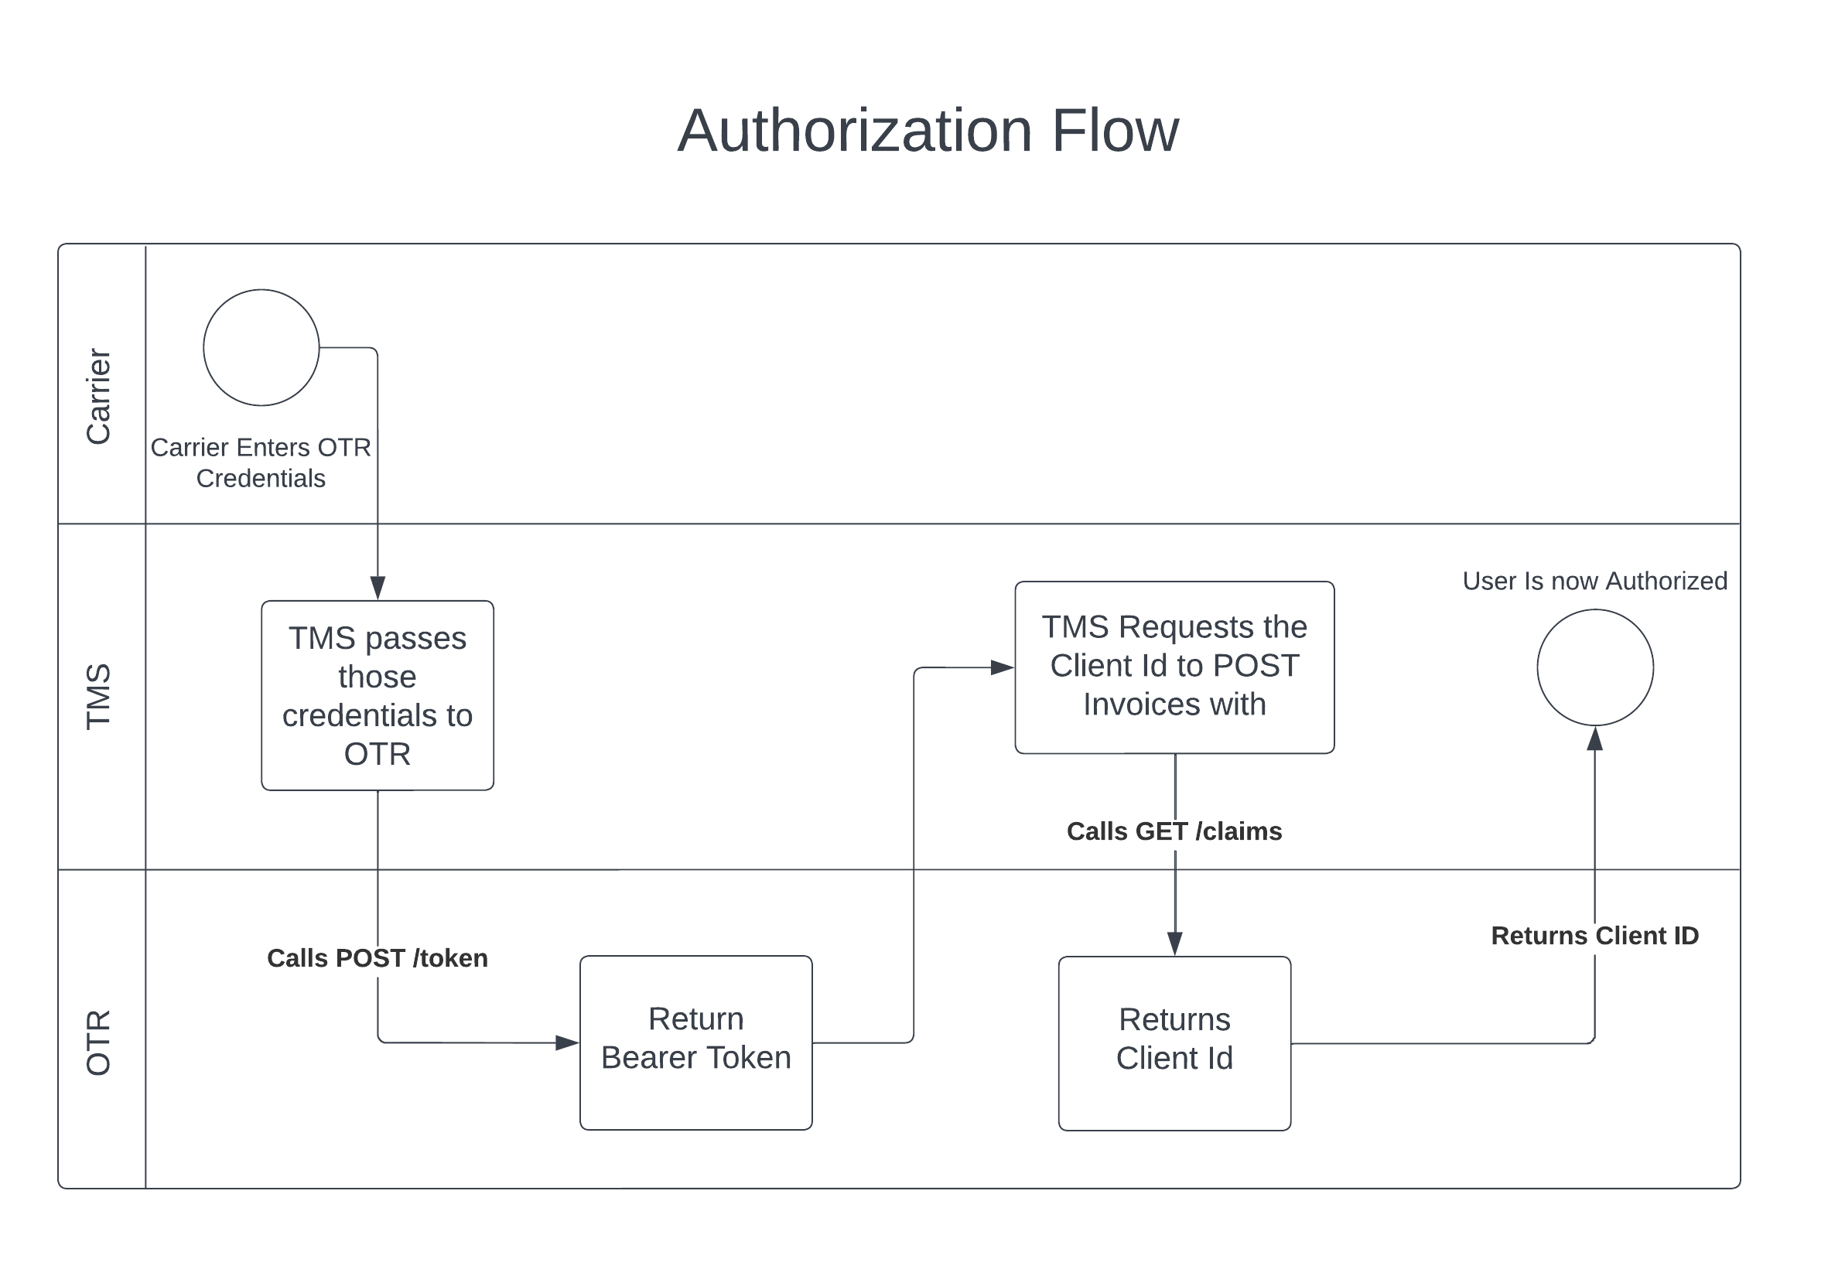

POST /token

In the response, you are given the bearer token to pass with the requests to have the system recognize what the user has access to on the OTR side. This is different from the Ocp-Apim-Subscription-Key which is to give access to the APIs. The Bearer token allows OTR to recognize who the client is inside our system. The refresh token is sent with token-refresh.

Request URL: https://servicesstg.otrsolutions.com/carrier-tms/auth/token
Headers:
Ocp-Apim-Subscription-Key -> This value is given by OTR to gain access to the API.
Content-Type -> application/x-www-form-urlencoded

Body:
username -> OTR Login Credentials
password -> OTR Login Credentials

Response:
{
"access_token": "TestBearerToken123141251251241241231231241",
"token_type": "bearer",
"expires_in": 7199,
"refresh_token": "15e3cc058d7a40aca24947c099d6e208"
}

GET /token-claims

Uses the Bearer Token to get the Client ID needed to post an Invoice.

Request URL: https://servicesstg.otrsolutions.com/carrier-tms/auth/token-claims
Headers:
Ocp-Apim-Subscription-Key -> This value is given by OTR to gain access to the API.
Authorization -> Bearer tokenreturnedinposttoken

Response:
{
"userID": "8493e101-7193-4b34-991d-51259fc5eb10",
"clientID": 24134
}

POST /token-refresh

This endpoint can be used to refresh the bearer token before it times out.

Request URL: https://servicesstg.otrsolutions.com/carrier-tms/auth/token-refresh
Headers:
Ocp-Apim-Subscription-Key -> This value is given by OTR to gain access to the API.
Authorization -> Bearer tokenreturnedinposttoken

Body:
refresh_token -> refreshtokenreturnedinposttoken

Response:
{
"access_token": "TestBearerToken123141251251241241231231241",
"token_type": "bearer",
"expires_in": 7199,
"refresh_token": "15e3cc058d7a40aca24947c099d6e208"
}

Broker

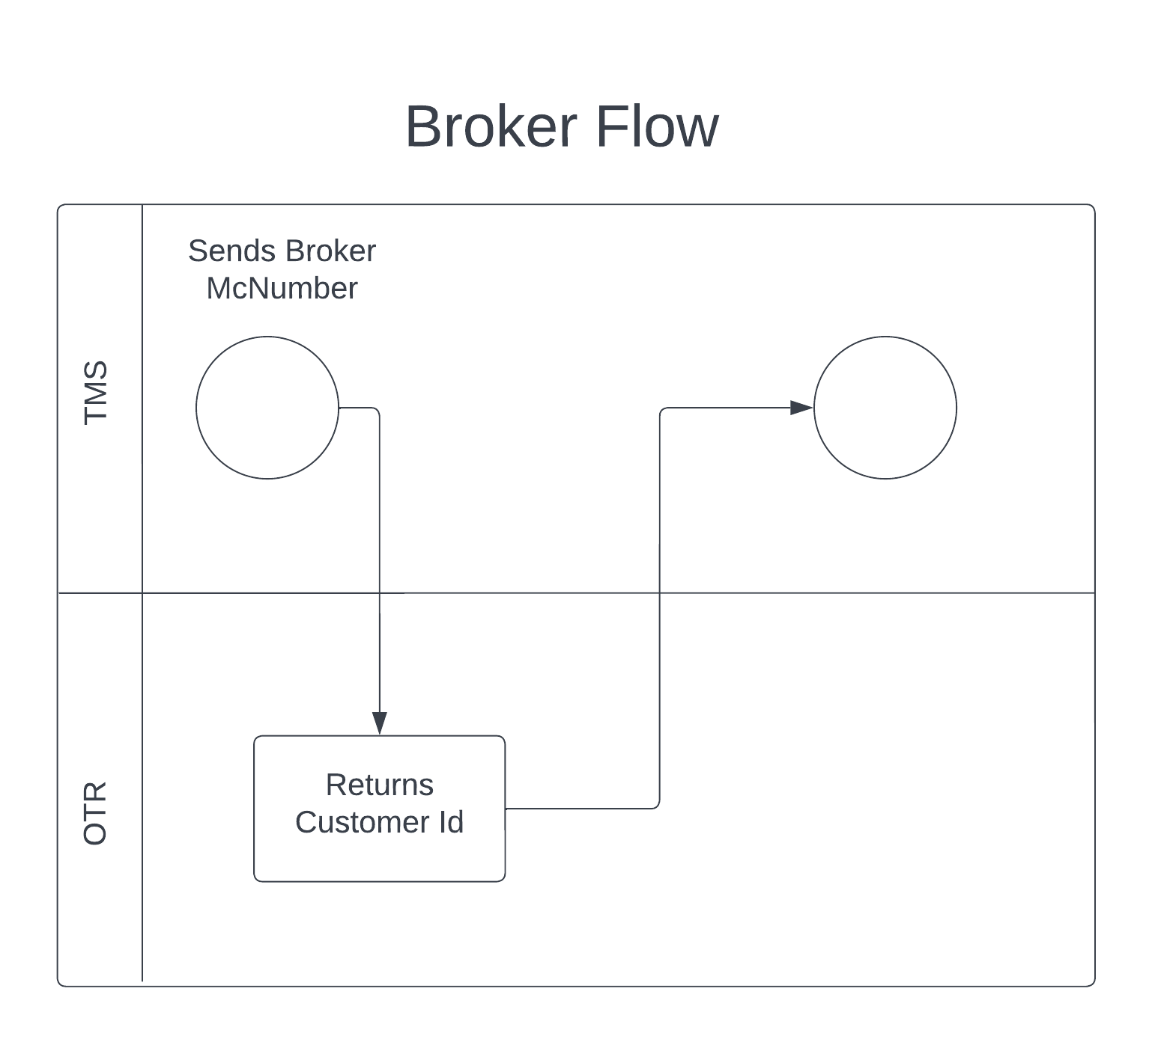

GET /customers
Search our list of Customers for the McNumber Provided. Used to get the CustomerPKey which is needed to post an invoice to that customer. It will return a list of Customers that match that McNumber.

Request URL: https://servicesstg.otrsolutions.com/carrier-tms/customers
Headers:
Ocp-Apim-Subscription-Key -> This value is given by OTR to gain access to the API.
Authorization -> Bearer tokenreturnedinposttoken

Response:
[
{
"PKey": 31583,
"McNumber": "",
"DotNumber": null,
"Name": "*-",
"Address": "",
"City": "",
"State": null,
"ZipCode": "",
"NeedsOriginal": false,
"Phone": null,
"Factorable": true,
"CreditCheckResult": null,
"RecourseNoBuy": false
},
{
"PKey": 29923,
"McNumber": "",
"DotNumber": null,
"Name": "******",
"Address": "",
"City": "",
"State": null,
"ZipCode": "",
"NeedsOriginal": false,
"Phone": null,
"Factorable": true,
"CreditCheckResult": null,
"RecourseNoBuy": false
}
]

Invoice
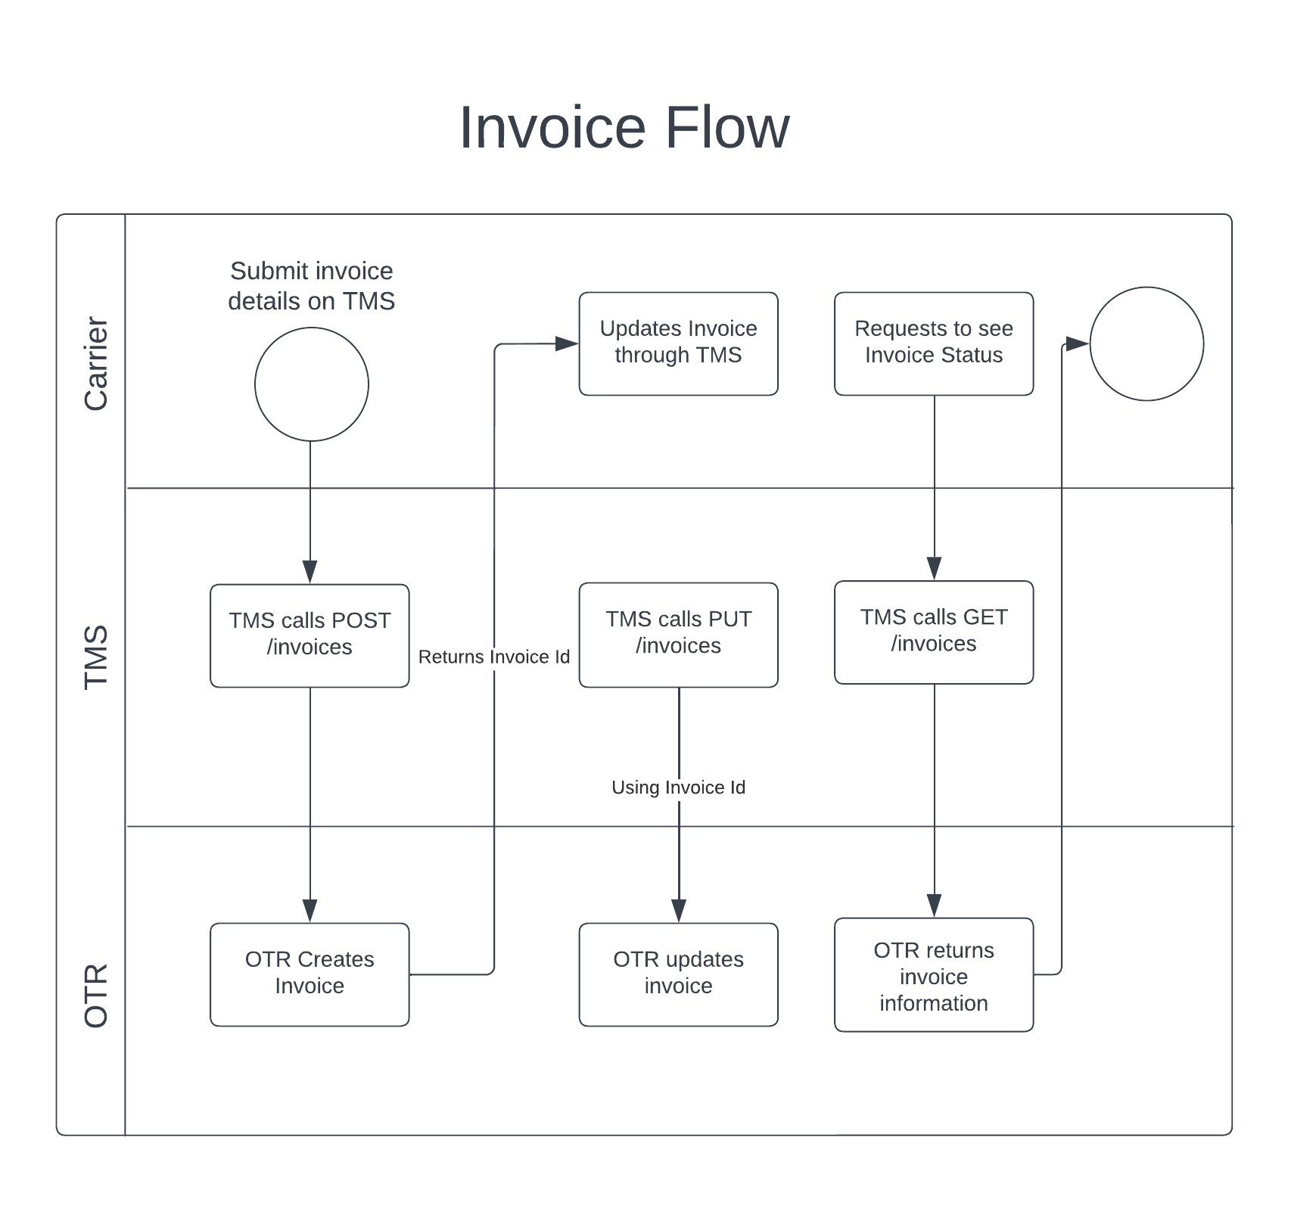

POST /invoices
Post invoice details to OTR to create an invoice. This invoice can be updated through the PUT statement with additional documents and information after.

Request URL: https://servicesstg.otrsolutions.com/carrier-tms/invoices
Headers:
Ocp-Apim-Subscription-Key -> This value is given by OTR to gain access to the API.
Authorization -> Bearer tokenreturnedinposttoken
Content-Type -> multipart/form-data

Body:
ApiInvoiceDataJson -> Invoice data submitted as JSON
Files -> Paperwork needed for Invoice

Response:
{
"PKey": 9009937,
"StatusID": 1,
"Status": "Pending",
"CustomerPKey": 23739,
"CustomerName": "Test QA Only",
"InvoiceDate": "2022-12-20T19:50:14.4048337+00:00",
"CreatedDate": "2022-12-20T19:50:14.4985834+00:00",
"CustomerMCNumber": "7357040717",
"InvoiceAmount": 70.0,
"AdvanceRequestAmount": 0.0,
"AdvanceRequestType": "",
"PoNumber": "426",
"FactorType": null,
"InvoiceNumber": "706",
"ShipFromCity": null,
"ShipFromState": null,
"ShipToCity": null,
"ShipToState": null,
"Phone": null,
"InvoiceLines": [],
"InvoiceLanes": [],
"CarrierInvoiceLanes": [],
"CarriernInvoiceLines": [],
"InvoiceAdvances": [],
"InvoiceAdvance": null,
"Files": []
}

PUT /invoices

This goes to the same endpoint as the POST but in the JSON you must specify the InvoicePKey that is returned as part of the response in the POST. The Headers, Body, and Response are all the same.
Request URL: https://servicesstg.otrsolutions.com/carrier-tms/invoices

GET /invoices/{id}

This endpoint can be used to see updates on the created invoice. Pass the PKey that was returned in the POST response. The status of the invoice in the OTRs system can also be seen in the response. It is returned in two fields: StatusID and Status. Status ID is a number from 1-8 that represents the status passed in the field Status.
Status Values:
Id | Status
1 | Pending
2 | Adv Issued
3 | Approved
4 | Dead
5 | Addendum
6 | Issue Client
7 | Duplicate
8 | Issue Followup

Request URL: https://servicesstg.otrsolutions.com/carrier-tms/invoices/{id}
Headers:
Ocp-Apim-Subscription-Key -> This value is given by OTR to gain access to the API.
Authorization -> Bearer tokenreturnedinposttoken

Response
{
"PKey": 9008568,
"StatusID": 1,
"Status": "Pending",
"CustomerPKey": 23739,
"CustomerName": "Test QA Only",
"InvoiceDate": "2022-08-26T08:43:16.31",
"CreatedDate": "2022-08-26T08:43:16.323",
"CustomerMCNumber": "7357040717",
"InvoiceAmount": 70.0,
"AdvanceRequestAmount": 0.0,
"AdvanceRequestType": "",
"PoNumber": "31",
"FactorType": "REG",
"InvoiceNumber": "456",
"ShipFromCity": null,
"ShipFromState": null,
"ShipToCity": null,
"ShipToState": null,
"Phone": null,
"InvoiceLines": [],
"InvoiceLanes": [],
"Files": [],
"CarrierInvoiceLanes": [],
"CarriernInvoiceLines": [],
"InvoiceAdvances": [],
"InvoiceAdvance": null
}

Broker Check
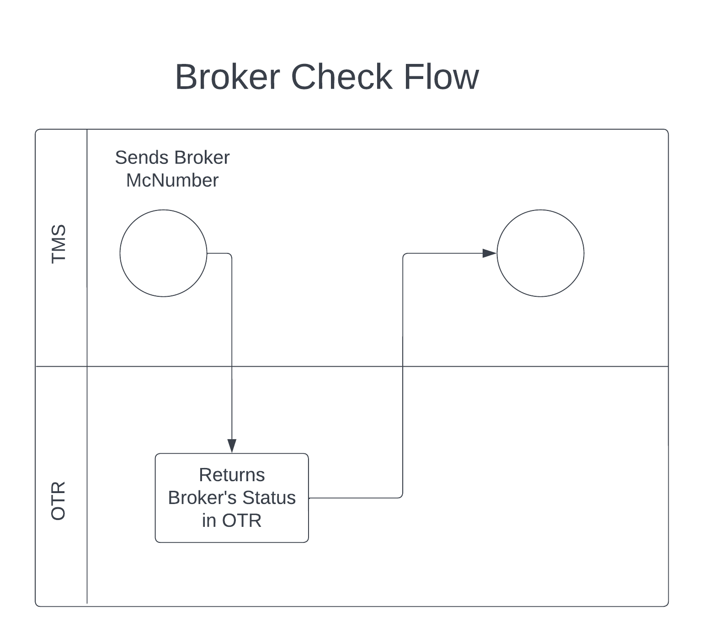

GET /broker-check/{id}
This endpoint can be used to fetch OTR’s status of a broker’s credit. Having this can allow a carrier to know if they can factor through that broker with OTR.

Request URL: https://servicesstg.otrsolutions.com/carrier-tms/broker-check/{id}
Headers:
Ocp-Apim-Subscription-Key -> This value is given by OTR to gain access to the API.
Authorization -> Bearer tokenreturnedinposttoken

Response:
{
"id": "1468",
"Name": "TestCompany",
"McNumber": "12345",
"BrokerTestResult": "Call Credit",
"NoBuy": false,
}

