OTR Solutions
API Reference Documentation

Document Version 1.1
January 2023

Key Processes 3
Overview 3
API Specifications 4
Integrating with OTR 4
Getting Credentials 4
Authorization 4
Testing 4
Going Live with new Integrations 4
Production Support 4
Authentication 5
POST Token 5
GET Claims 6
Onboarding 7
GET Authority Information 7
POST General Account 8
POST Account 9
POST Account Verification 10
Links 11
Version History 11

Key Processes

Overview
OTR Solutions has developed an integration pattern to share key entities and attributes frequently requested by vendors wanting to integrate with our authorization and onboarding processes. Our APIs support the following key processes:
- Onboarding OTR Customers
- Authenticating OTR Customers
We are proposing a standard process flow for onboarding OTR Customers and authenticating their subsequent logins. The following this is a detailed breakdown of each step within this cycle:
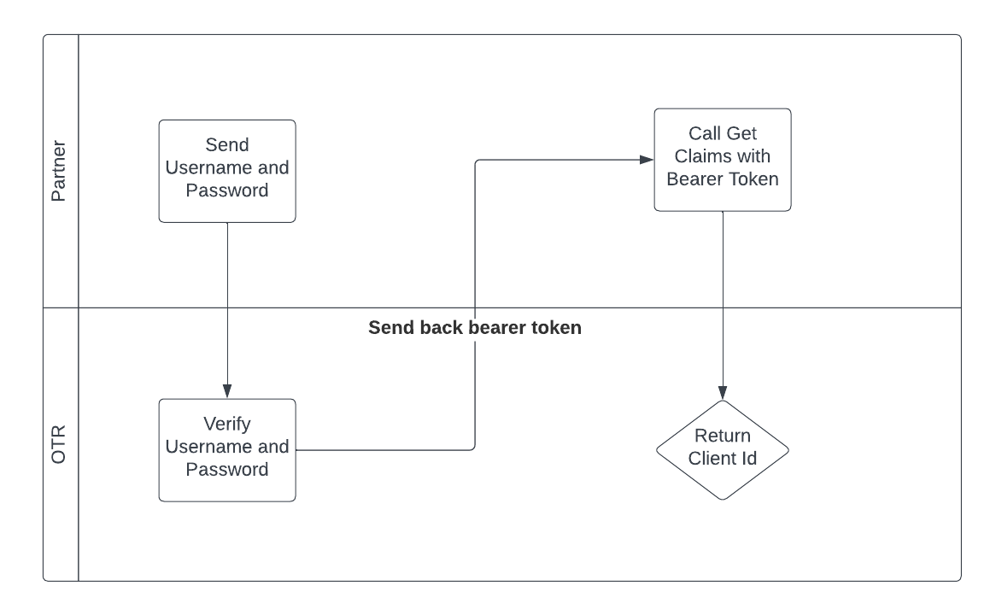

Onboarding Overview
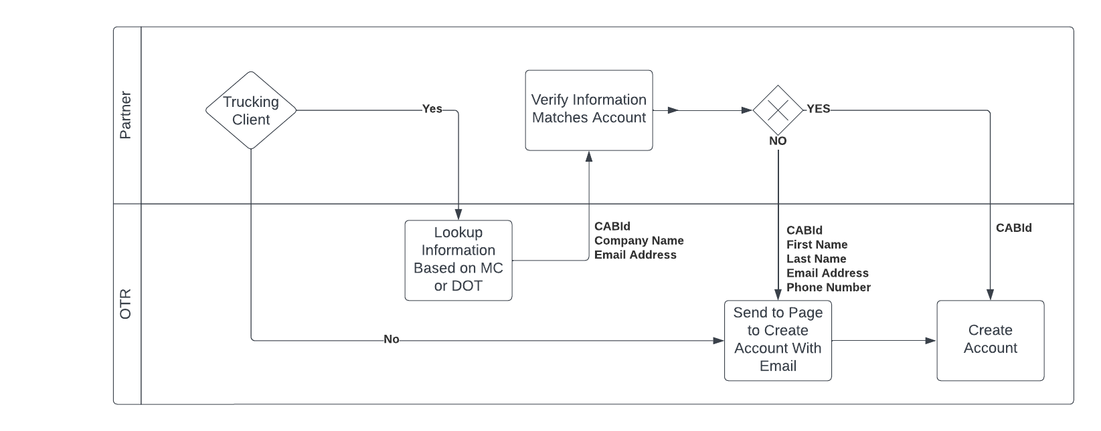

API Specifications

Integrating with OTR

Getting Credentials
- Send an email to integrations@otrsolutions.com explaining who you are and what APIs you would like access to.
- Pending an internal review, we will provide you with a subscription key to access our APIs.

Authorization
- The Subscription key will give you access to reach our testing environment. We will also provide an account to our developer portal which will have up to date API specs for what you have requested. Using these specs our future partners can test and validate how to create and get information from OTR.

Testing
- When you are ready to begin testing, email integrations@otrsolutions.com to coordinate a Project Timeline meeting with OTR.
- Verify and test with the provided credentials and reach out to integrations@otrsolutions.com with any questions that come up.
- Once testing is nearing completion, email integrations@otrsolutions.com to coordinate a Go Live meeting with OTR.

Going Live with new Integrations
- OTR will want to market the new partnership, so we ask that you give a minimum of 30 days notice of intent to Go Live to allow our team to prepare accordingly. On day of the Go Live, OTR will monitor for potential issues on our end.
- Please reach out ASAP if the date needs to change or if any issues arise
- After the Go Live, OTR will monitor and send daily reports. OTR will schedule weekly meetings for 1 month to give and receive feedback regarding the integration. The sessions may continue if both parties continue to find them valuable.

Production Support
- OTR will continue monitor the new integration at regular intervals and reach out with any problems.
- All new or updated APIs will be updated on our developer portal. Notification around any updates will be communicated by OTR no less than 30-days in advance of deployment of new or updated APIs. A detailed coordination meeting can be setup between both parties if needed.

Authentication

POST Token
- Authenticate sign-ins with OTR and retrieve a bearer token associated with the user

Headers
ocp-apim-subscription-key | String | Required | Authentication key used to hit our API endpoints

Request Data
Key | Type | Required/Optional | Description
username | String | Required
password | String | Required

Response
Sample Post Token Response:
{
"access_token": "9H1FAk0ehBuTOy_2_XJX4qsSQnuxmAC67BPlUSyhPgICIutLkVbEvrsFWQGQnCYCegn05FFO9xDLSdw8srfI7mRT-9Mn8H4yliqXUTKVemoCX02oDVKaBZ3gpAoSQwqfyk3TjGR2JwZqCS6Gaul4d_YcNkrELtiLq1QwrI67hwtPDi25lqNQfgYb9zH3QNdM3S7Hnipt-wikcnrLBWuKV0i57Mwx3EpHzTvB2EttVh8WcPwY6df9ObpB1yRAqpMfxTliQCoJ4yLJn74P4iseLepTcmYWpbIEoYK4TOH2G8N9xxBBWjyQuH_JKJbnR8yaJQp_zsfO2_BT4tbEbUMyi2M8nFZX5phYpE3PDhIJEjVNVH-lH8P8fDT01v3qTSZI74RFZdzmGAzOXpcT6GO2GJkj-mpK-7HgsyV_LvtzDGBq2taWcHQr2BDcz_qv-mb3IBcb-uZySzxiq5AWkmk9A2pDyqTZ3t9uNCjUyFlAPrFrUhYp-tInbbwUA33434fed9JeJshmYpNGr9YtOWB-0Je7c7ijQYMQ1Q36YFDnU9bOJC09GdSTrq__aF4hIQFOR7d8_DXCh27LNkFQSHY-E_eDqomj5kt22upsDOzF==",
"token_type": "bearer",
"expires_in": 7199,
"refresh_token": "7a7cd7efaddb49149432d2924d65a00a"
}

GET Claims
- Retrieve the Client's Id from OTR's system along with the user roles associated with the user

Headers
ocp-apim-subscription-key | String | Required | Authentication key used to hit our API endpoints
Authorization | Bearer {access_token} | Required | Access token returned from POST Token

Response
Sample Get Token Claims Response:
{
"userID": "51fc3020-fe3a-4e59-9d33-a53006f86a6f",
"clientID": 150317,
"roles": [
"Client Admin"
]
}

Onboarding

GET Authority Information
- This looks up the user's authority via either a DOT number OR an MC number

Headers
ocp-apim-subscription-key | String | Required | Authentication key used to hit our API endpoints

Request Data
Query Parameters | Type | Required/Optional | Description
dot | String | Required | Either DOT OR MC are required
mc | String | Required | Either DOT OR MC are required
isTest | boolean | optional | This identifies the lead as a test lead in salesforce. USE ONLY DURING INTEGRATION TESTING

Response
Sample Get Prospects Response:
{
"CabId": "string",
"FirstName": "string",
"LastName": "string",
"Company": "string",
"Street": "string",
"City": "string",
"PostalCode": "string",
"StateCode": "string",
"CountryCode": "string",
"Phone": "string",
"MobilePhone": "string",
"Email": {},
"MotorCarrierNumber": {},
"DotNumber": "string",
"DbaName": {}
}

POST General Account
- If user Submits an account if it is not a trucking client, or if the user would like to use information that doesn’t match their MC OR DOT information from the GET Authority Information call.

Headers
ocp-apim-subscription-key | String | Required | Authentication key used to hit our API endpoints

Request Data
Query Parameters | Type | Required/Optional | Description
isTest | boolean | Optional | Is this test data

Request:
{
"email" : "autho@yopmail.com",
"phone" : "5555514896",
"first_name" : "Auth",
"last_name" : "Test",
"company" : "CompanyAuth"
}

Response
Sample Post Lead Response:
Lead has been submitted

POST Account
- User's account is created based on the CAB Id

Headers
ocp-apim-subscription-key | String | Required | Authentication key used to hit our API endpoints

Request Data
Key | Type | Required/Optional | Description
cab-id | string | Required | User's CAB Id

POST Account Verification
- Sends an email to the client with a 6-digit code verify their email and allow them to setup their password

Headers
ocp-apim-subscription-key | String | Required | Authentication key used to hit our API endpoints

Response
Sample Post Prospect Verification Response:
{
"email": "string",
"cabId": "string",
"verificationId": "string"
}

Links
A full JSON file can be found on our developer portal at https://developer.otrsolutions.com

Version History
Date | Version | Notes | Author
2/21/2023 | v 1.0 | Created PayCard Document and added Authentication Endpoints | Graham Schunk
2/22/2023 | V 1.1 | Updated the endpoint information | Graham Schunk

